# CS 340 README Template

## About the Project/Project Title

This project allows a user to see dog breads in a database based on the dog compatibility with a specific job in a rescue type environment .

## Motivation

This is to have an easy display and locate-ability of dogs that are available for adoption.

## Getting Started

To use the site:

First download the zip file that contains the python files, MongoDB_crud, ProjectTwoDashboard and the logo.

When accessing the ProjectTwoDashboard on the local computer browser it will allow you access to the animal database to search and filter dogs based on breed, age and type.

## Installation

Access to the Project2 cs340 zip file.

## Usage

*Use this space to show useful examples of how your project works and how it can be used. Be sure to include examples of your code, tests, and screenshots.*

### Code Example

N/A This is a browser script that will not need code injections.

### Tests

Using the files you can select dogs and filter based on breed, age, adoption status, and location.

### Screenshots

Reset view:

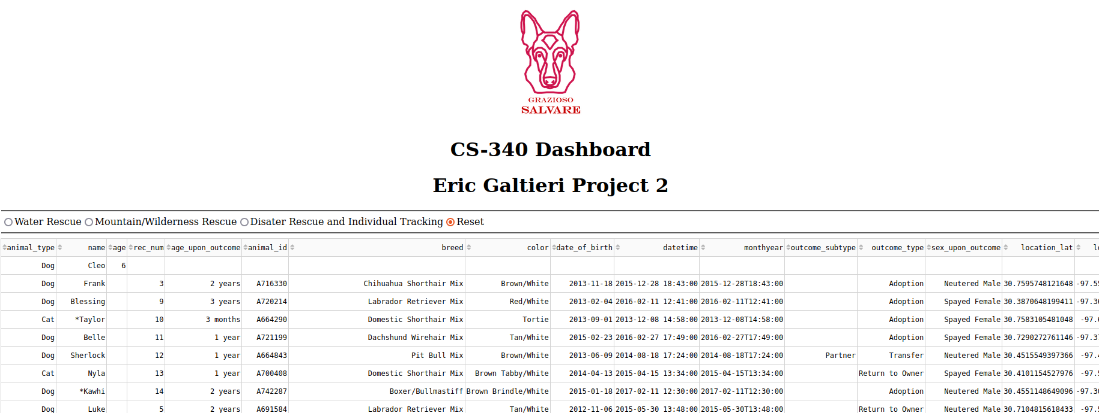

Disaster view:

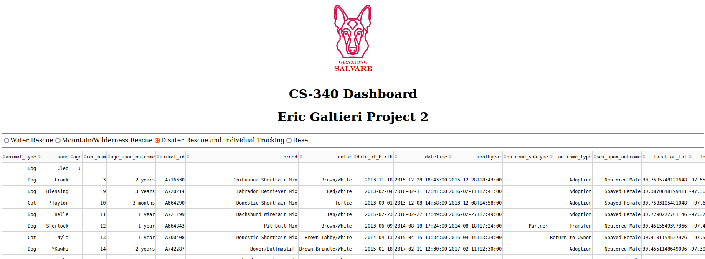

Mountain View:

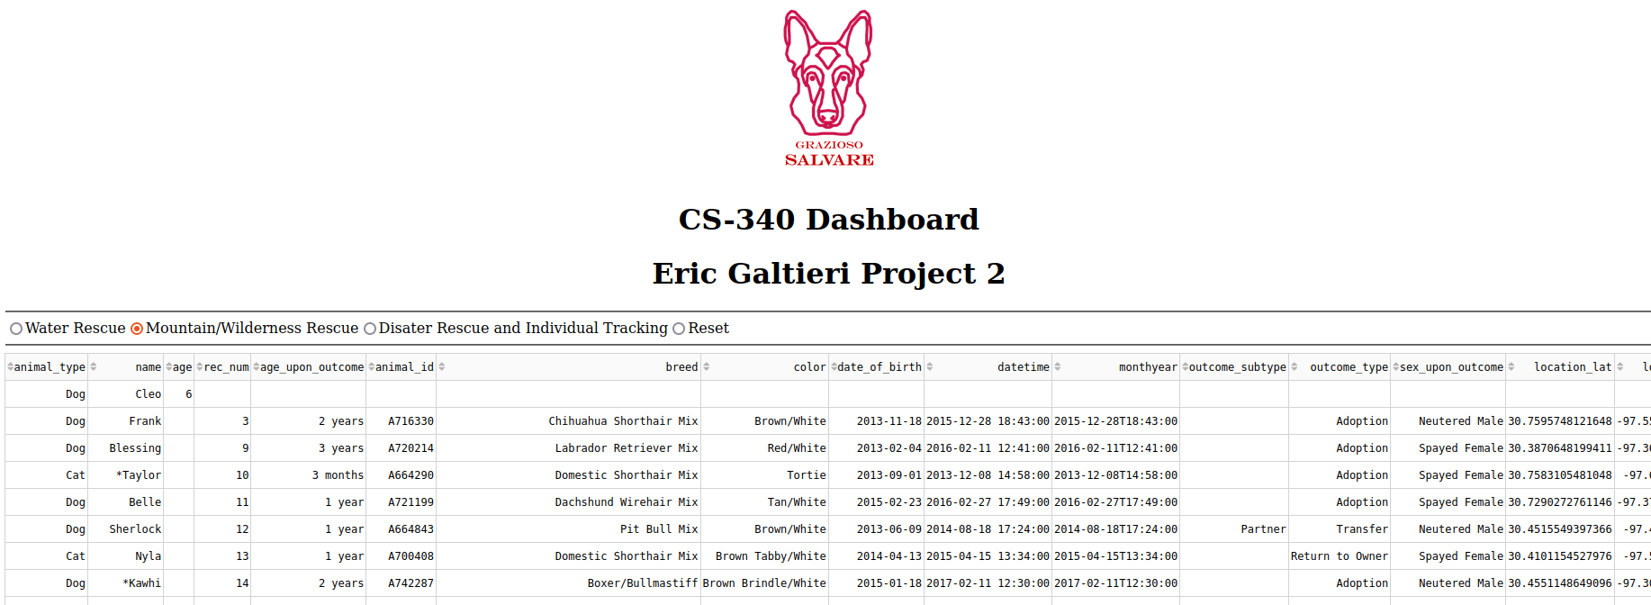

Water view:

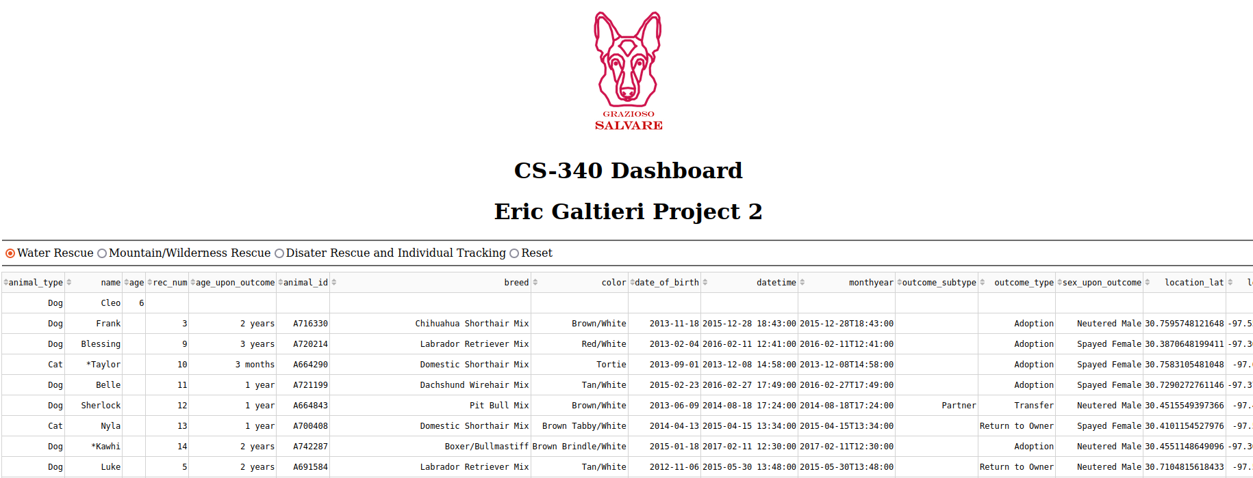

## Contact

Your name: Eric Galtieri